Adding Individual Students to a Class

1. Hover over the class icon on the left side of the screen and then select “Configuration”  
   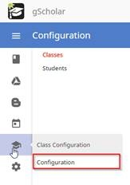
2. This will bring up a list of your classes. If you hover over the class you want to add a student to, you’ll see a green plus sign come up that you’ll want to click.

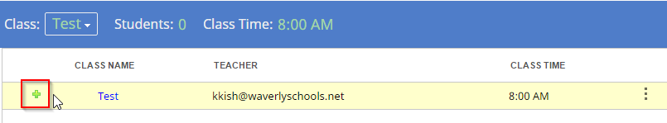

1. This will bring up the following window. If you type in the student’s email account, <student number>@waverlyschools.net, and then click “Add” they will be added to your class.

