gScholar: creating new classes
First, you’ll need to log into gScholar at https://promevogscholar.appspot.com with your waverlyschools.net teacher account.
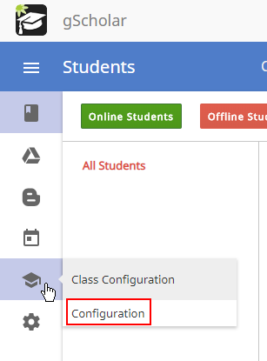
- In the left pane hover your mouse over the graduation cap icon to expand Class Configuration. Then click “Configuration”

- If you’re not already displaying your classes, then click on “Classes”

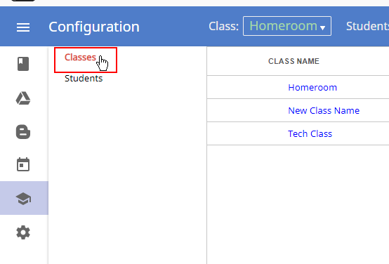

- Then in the upper right corner, click the plus sign to create a new class.
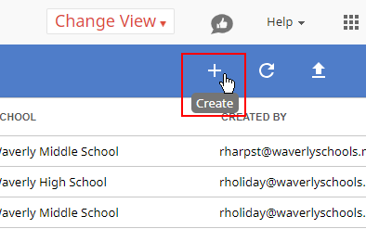

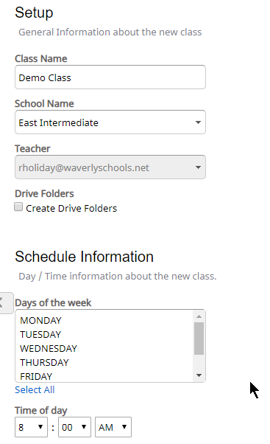
- Now give your class a name and select your school. You can automatically create Google Drive folders for this class which will show in you and your student’s Google Drives.
Selecting the days of the week your class runs is optional, but can be useful if you have classes that don’t run every single day.

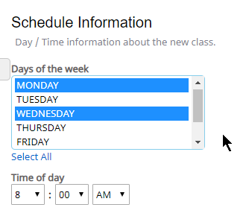
- You can select multiple days by clicking on “Select All” or holding the ctrl button on your keyboard while clicking on the days.

- After you have everything finalized. Click the check mark in the upper right corner of the screen to save the class. This may take a minute after clicking.
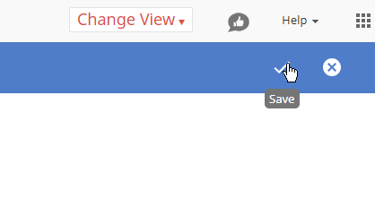

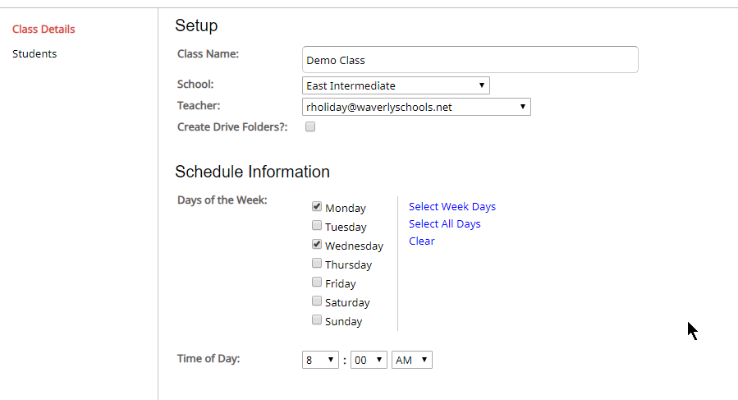
- Now you should see your new class in your class list from step 2. When you click on the class, you can adjust the name, days of the week and time.

As always if you experience difficulty, give us a holler at the Help Desk (517-244-1215) and we’ll get you squared away.

