Syncing OneDrive for Business

Why Sync?
OneDrive lives in the cloud and gives you access to your documents anywhere you have internet access. Performing a sync provides several added benefits.
- Keeps a local copy of all your files. This makes files accessible even if you are offline.
- Provides an easy way to manage documents (copy, paste, drag & drop reorganization).
- Provides an easy way to save documents directly from Microsoft Office. An OneDrive icon will show up in Windows Explorer, much like a drive letter.

Step 1 – Login to OneDrive using Internet Explorer
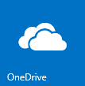
You can find OneDrive by logging into SharePoint, clicking on the app launcher and selecting OneDrive tile.

Step 2 – Click ‘Sync’
In the top feature bar, click on the Sync option.

Step 3 – Confirm
Confirm you desire to sync your OneDrive by clicking on Sync now.
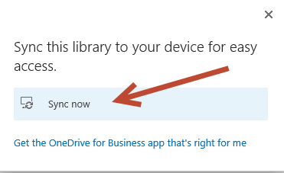

Step 4 –Ready to Sync
Click Sync now
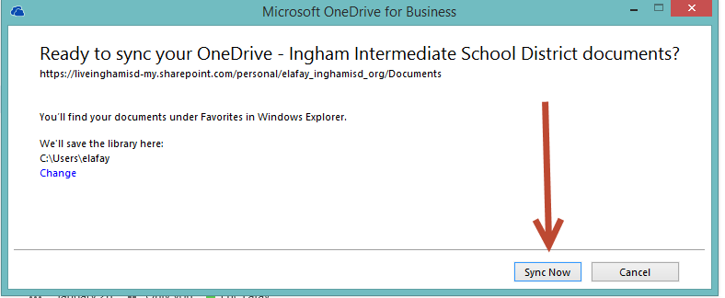

Step 5 – Confirmation
Depending on how many files are currently in your OneDrive, the first sync may take a while to complete.

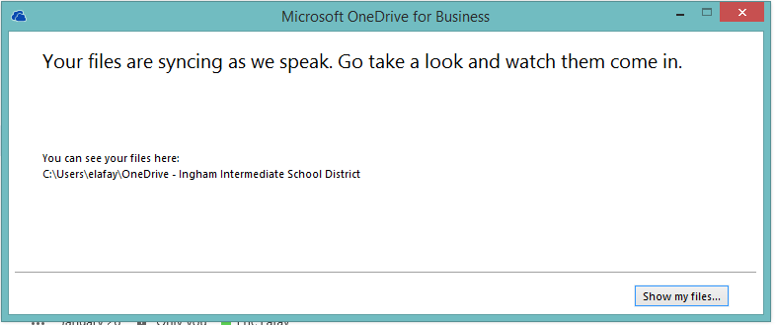

You can view the progress by clicking on OneDrive for Business in Windows Explorer
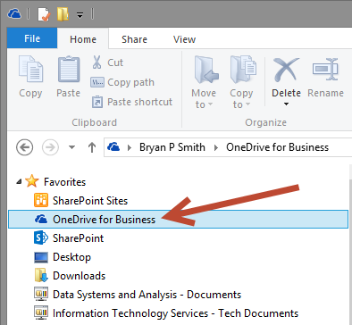
In Sync - Folders & Files that are in Sync with the cloud, will be represented with a green check mark.

Synchronizing - Folders & Files that are currently being synchronized will have blue arrows.
Errors – If there is a problem synchronizing a folder or a file, it will be represented by a red x.

Ready to go…
Once you are synced, you can use your local OneDrive just like your previous home drive. You can copy / paste documents and they will automatically synchronize with the cloud.

If you need help…
If you encounter a problem along the way, please contact the help desk at 517.244.1215. Additionally, the help desk can assist if you have any errors with the sync (as indicated by the red x).

